Ex:No: 12

Date:

**TCL COMMANADS**

**Aim:**

To learn how to use various TCL commands Commit, Rollback and Savepoint

SQL commands

**Syntax:**

ROLLBACK TO savepoint_name;

SAVEPOINT command

SAVEPOINT command is used to temporarily save a transaction so that you can rollback to that point whenever required.

**Syntax:**

SAVEPOINT savepoint_name\\;

**Problem 1:**

Rollback to that state using the ROLLBACK command whenever required.

Create a following table Class and insert values into it in the order and create savepoints in between them. Try to rollback t the save point and check your output by giving select commands.

Let us use some SQL queries on the above table and see the results.

INSERTINTO class VALUES(5,'Rahul');

COMMIT;

UPDATE class SET name ='Abhijit' WHERE id ='5';

SAVEPOINT A;

INSERTINTO class VALUES(6,'Chris');

SAVEPOINT B;

INSERTINTO class VALUES(7,'Bravo');

SAVEPOINT C;

The resultant table will look like,

Now let's use the ROLLBACK command to roll back the state of data to the savepoint B.

ROLLBACKTO B;

SELECT*FROM class;

Now our class table will look like,

Now let's again use the ROLLBACK command to roll back the state of data to the savepoint A

ROLLBACKTO A;

SELECT*FROM class;

Now the table will look like,

**Queries:**

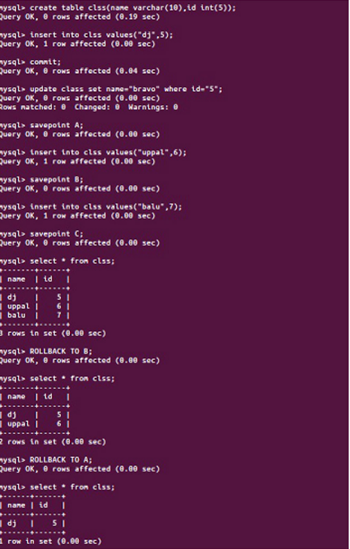

**Result:**

So now we know how the commands COMMIT, ROLLBACK and SAVEPOINT works.